Spring Integration

Background
Method of thinking software production as set of events and messages instead of service-oriented.

Spring Integration offers a lightwight, noninvasive, and declarative model for constructing message-driven applications.

To understand SI read: Enterprise Integration Patterns.

The patterns are what SI supports, the Spring programming model is how it supports them.

Spring Integration consists of two parts: messaging framework and adapter-based platform that supports flexible integration of applications across the enterprise.

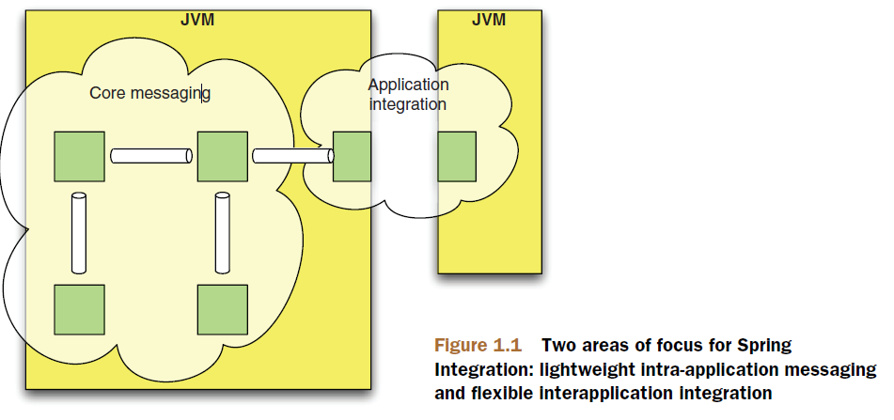

NOTE: inbound=source; outbound=target

SI helps us to apply universally applicable characteristics of good software design: low coupling and high cohesion.

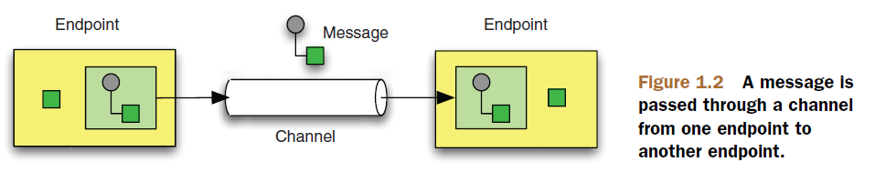
Messages
A message is a unit of information that can be passed between different components, called message endpoints.

Each message consists of headers and a payload. The header contains data that's relevant to the messaging system, such as the Return Address or Correlation ID. The payload contains the actual data to be accessed or processed by the receiver.

Messages Channels
The message channel is the connection between multiple endpoints. The channel implementation manages the details of how and where a message is delivered but shouldn't need to interact with the payload of a message.
Channels may be classified according to whether messages are point-to-point or publish-subscribe.

Message endpoints
Message endpoints are the components that actually do something with the message. This can be as simple as routing to another channel or as complicated as splitting the message into multiple parts or aggregating the parts back together. Connections to the application or the outside world are also endpoints, and these connections take the form of channel adapters, messaging gateways, or service activators.

Message Endpoints are components that separate business logic from the messaging framework. They are crucial in the integration space for hiding the messaging details. They are responsible for connecting application components to the messaging channels to send or receive messages.

Spring Integration provides endpoints such as Service Activators, Channel Adapters, Message Bridges, Gateways, Transformers, Filters, and Routers.

Message Bridge
A MessageBridge is a simple endpoint that couples different messaging modes or adapters. An example of a common use of the bridge is to tie up a point-to-point (P2P) mode channel to a Publish/Subscribe (Pub/Sub) mode.

Message Enricher
A Message Enricher component enriches the incoming message with additional information and sends the updated object to the downstream consumer. There exist two types of enriching messages: Header Enricher and Payload Enricher.

Gateway
Layer che si trova tra il client che invia dati e l'infrastruttura di integrazione che si occuperà del loro trasporto.
Il Gateway ha come obiettivo quello di disaccoppiare il client dall'infrastruttura di integrazione.
Il Gateway è un punto di ingresso per l'infrastruttura gestita da Spring Integration.
Si occupa di gestire l'indirizzamento del messaggio in input sulla infrastruttura di integrazione affinchè raggiunga l'endpoint a cui è destinato.
When you use the Gateway pattern, you ill not be using any of the messaging components, but will be dealing with a simple interface that will expose your functionality.

There are two types of Gateways: Synchronous Gateway and Asynchronous Gateway.

Delayer
The Delayer endpoint is used to introduce delay between sender and receiver.

Hello Spring Integration
Spring Integration aims to provide a clear line between code and configuration.
The components provided by the framework, which often represent the enterprise integration patterns, are typically configured in a declarative way using either XML or Java annotations as metadata. But many of those components act as stereotypes or templates. They play a role that's undestood by the framework, but they require a reference to some user-defined, domain-specific behavior in order to fulfill that role.

Messaging
With Spring Integration, messages are exchanged through channels between designated endpoints of application components as well as external systems.

NOTE: Message is a pattern!!!

Besides the application data, which is destined to be consumed by the recipient, a message usually packs meta-information. The meta-information is of no interest to the application per se, but it's critical for allowing the infrastructure to handle the information correctly. We call this meta-information message headers.

Types of messages:
- Document msg
- Command msg
- Event msg

A message is a generic wrapper around data that's transported between the different components of the system. The wrapper allows the framework to ignore the type of the content and to treat all messages in the same way when dealing with dispaching and routing.

package org.springframework.integration;

public interface Message<T> {
MessageHeaders getHeaders();
T getPayload();
}

The content wrapped by the message can be any Java Object, and beacause the interface is parameterized, you can retrieve the payload in a type-safe fashion.

The MessageHeaders are a Map with some additional behavior. Their role is to store the header values, which can be any Java Object, and each value is referenced by a header name:

package org.springframework.integration;

public final class MessageHeaders implements Map<String, Object>, Serializable {
/* implementation omitted */
}

Note: Message and MessageHeaders aren't modifiable.

MessageBuilder
The Spring Integration's MessageBuilder creates messages from either a given payload or another message (a facility necessary fro creating message copies). There are three steps in this process:
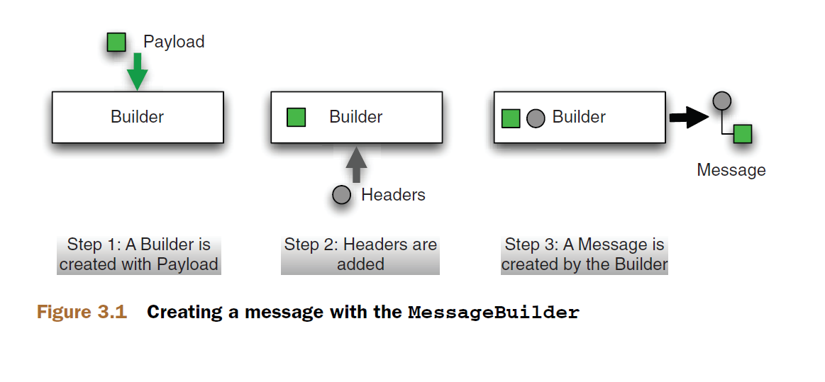
Steps 1 and 3 are mandatory in that they have to take place whenever a new message is created using MessageBuilder, whereas step 2 is optional and needs to be performed only when custom headers are required. It should be noted that the MessageBuilder initilizes a number of headers that are needed by default by the framework, and this is in one of significant advantages of using the MessageBuilder over instantiating messages directly: you don't have to worry about setting up those headers yourself.
As an example, creating a new message with a String payload can take place as follows:

Message<String> helloMessage = MessageBuilder.withPayload("Hello, world!").build();

The MessageBuilder also provides a variety of methods for setting the headers, including options for setting header value only if that header hasn't already been set. Example:

Message<String> helloMessage = MessageBuilder.withPayload("Hello, world!")
.setHeader("custom.header", "Value")
.setHeaderIfAbsent("custom.header2", "Value2")
.build();

Channels
Channels are like mailing system!!!!
One distinctive trait of Spring Integration, which differentiates it from other enterprise integration frameworks, is its emphasis on the role of channels in defining the enterprise integration strategy. Channels aren't just information transfer components; they play an active role in defining the overall application behavior. The business processing takes place in the endpoints, but you can alter the channel configuration to completerly change the runtime characteristics of the application.

All channels in Spring Integration implement the following MessagChannel interface (note that it provides no methods for receiving messages):
package org.springframework.integration; (in spring4: org.springframework.messaging)

public interface MessageChannel {
boolean send(Message<?> message);
boolean send(Message<?> message, long timeout);
}

The reason no methods are provided for receiving messages is because Spring Integration differentiates clearly between two mechanisms through which messages are handed over to the next endpoint – polling and subscription - and provides two distinct types of channels accordingly.

SubscribableChannel
Channels that implement the SubscribableChannel interface take responsability for notifying subscribers when a message is available:
package org.springframework.integration.core;

public interface SubscribableChannel extends MessageChannel {
boolean subscribe(MessageHandler handler);
boolean unsubscribe(MessageHandler handler);
}

PollableChannel
This type of channel requires the receiver or the framework acting on behalf of the receiver to periodically check whether messages are availabe on the channel.

package org.springframework.integration.core;

public interface PollableChannel extends MessageChannel {
Message<?> receive();
Message<?> receive(long timeout);
}

IMPORTANT: In Spring Integration, the default channels are SubscribableChannels, and the message transmission is synchronous.

IMPORTANT: The publish-subscribe channel doesn't support queueing, but it does support asynchronous operation if you provide a task executor that delivers messages to each of the subscribers in separate threads. This can also block the main thread or the application.
To avoid that you can connect the publish-subscribe channel by means of a bridge. The bridge is an enterprise integration pattern that supports the connection of two channels, which allows the publish-subscribe channel to deliver to the queue and then have the thread return immediately

Channel collaborators

MessageDispatcher

Depending on how messages are distributed to the different message handlers, we can have ither a competing consumers scenario or a broadcasting scenario.

In the broadcast scenario, multiple (or all) handlers will receive the message. In the competing consumers scenario, from the multiple handlers tha are connected to a given channel, only one will receive and handle the message.

The strategy for determining how the channel implemantation dispatches the message to the handlers is defined by the following MessageDispatcher inteface:

package org.springframework.integration.dispatcher;

public interface MessageDispatcher {
boolean addHandler(MessageHandler handler);
boolean removeHandler(MessageHandler handler);
boolean dispatch(Message<?> message);
}

Spring Integration provides two dispatcher implementation out of the box:
- UnicastingDispatcher: delivers to zero or one MessageHandler
- BroadcastingDispatcher: delivers to zero to more MessageHandler

Interceptors

For the monitoring scenario, Spring Integration provides WireTap, an implementation of the more Wire Tap enterprise integration pattern. It's easy to audit messages that arrive on a channel using a custom interceptor, but WireTap enables you to do this in an even less invasive fashion by defining an interceptor that sends copies of messages on a distinct channel.

Wire Tap Enterprise Integration Pattern
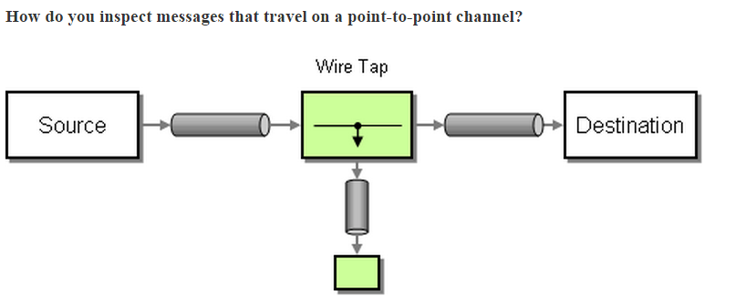

Endpoints
All message-handling components in Spring Integration, such as transformers, splitters, and routers, implement MessageHandler interface:

package org.springframework.integration.core;

public interface MessageHandler {
void handleMessage(Message<?> message);
}

To connect components to a channel, a certain amount of glue is necessary. In Spring Integration, that glue comes in the form of an adapter that understands how to interact with a given channel while delegating to a MessageHandler. The generic term for that adapter is message endpoint.

A few different kinds of adaptation are required depending on the type of channel and the role of the handler component being connected to that channel. If the channel is subscribable, the handler is invoked within the thread of the sender or by the channel's TaskExecutor if one is configured. For such a channel, no polling is required. If on the other hand the channel is one that buffers messages in a queue, such a QueueChannel, polling is necessary.

Endpoint classification

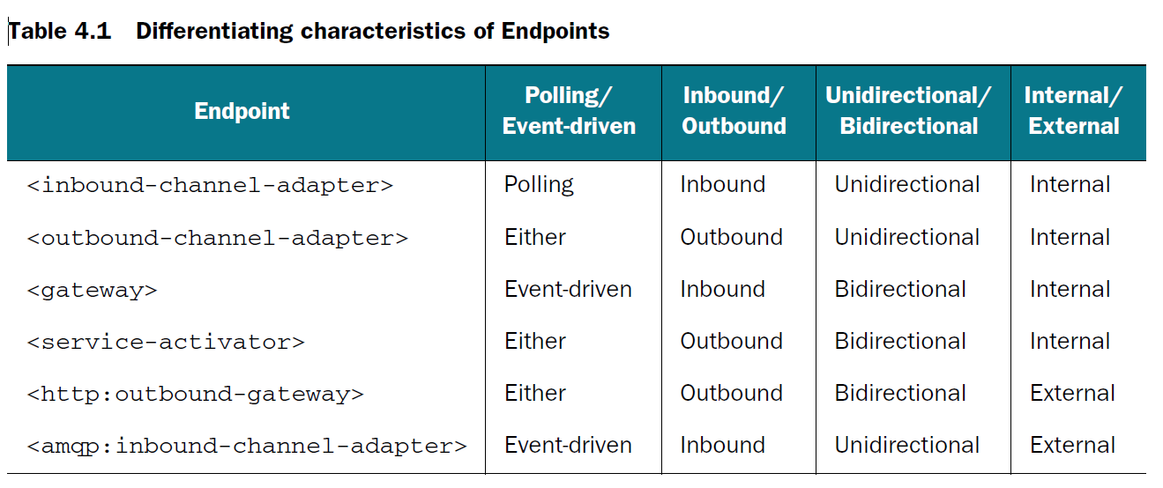

Polling endpoint

A polling endpoint will actively request new data to process. This data may be messages in a QueueChannel, files in a directory, messages in a JMS destination, and so on.

Event-driven endpoints

….

Inbound endpoints
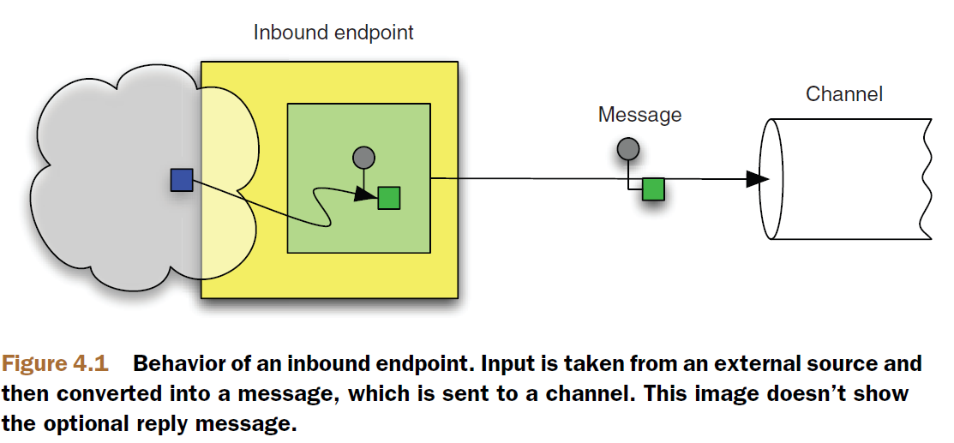

Transformers

Getting down to business

Filtering
To enable the selective consumption of messages, you can use a special type of message handler, a message filter. The filter is a message handler that evaluates messages without transforming them and publishes back to an output channel only the ones that satisfy a given rule.

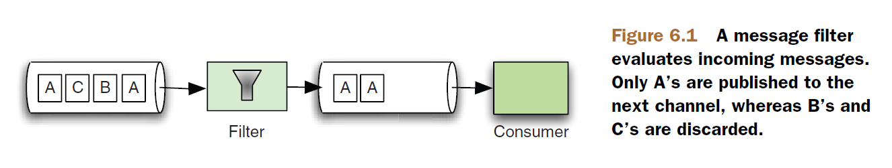

XML to Annotation

XML | Annotation
<int:gateway id=”i” service-interface=”IntName”> | @MessagingGateway(name=”i”)  public interface IntName
<int:channel id=”i”>

Sending mail

Glossary

unidirectional=channel adapter
bidirectional = gateway

murshalling = transform objects in cvs, json, xml
unmurshalling = transform cvs, json xml into java objects

Enterprise Messaging (book Pro Spring Integration pag. 393)
JMS is the current standard for the Java SE and Java EE.
Spring Integration comes with JMS support out of the box.
In JMS, there are two types of destinations: queue and topic:
- javax.jms.Queue for point-to-point communication
- javax.jms.Topic for publish/subscribe communication
Both classes extend javax.jms.Destination.

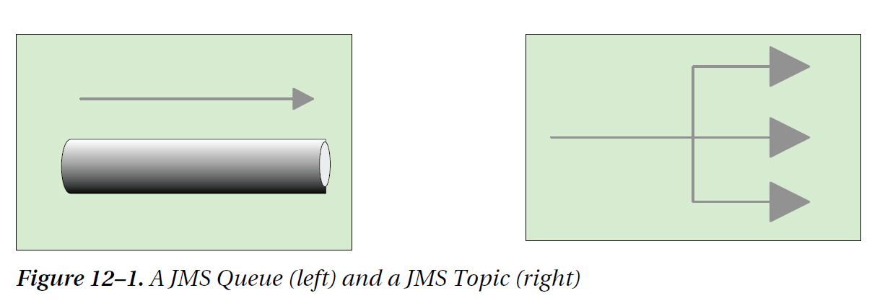

Appendix A

Endpoint | Description | Simbol
<inbound-channel-adapter> |  | 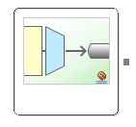

Message Routing

Using the terminology of Enterprise
Integration Patterns, all the routers provided by the framework are content-based routers.
This means the decision on where to send the message next is based solely on the contents
of the message.

